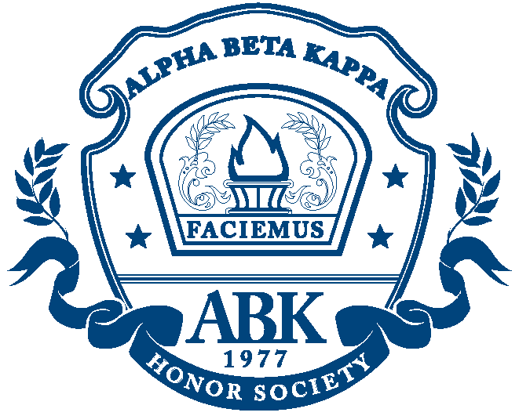

UNIVERSITY OF ADVANCING TECHNOLOGY
Beta of Arizona Chapter

OFFICIAL STUDENT APPLICATION FOR MEMBERSHIP

Date of graduation: ___________________

Print name as it should appear on your official Alpha Beta Kappa Certificate of Membership:

First: ______________________ Middle: _______ Last: ___________________________

Address: _______________________ City: ______________ State: _______ Zip: ______

Home Phone: ________________________ Email Address: ___________________

___ My membership for $38 is enclosed.

At the request of many honor students throughout the nation, Alpha Beta Kappa Honor Cords are also available! These five foot double-cords, which display the colors of the order, are red and blue. These cords are triple bound (two red bands and one blue band) and include variegated tassels. To order your cord, please include an additional $10.

___ Please include an Alpha Beta Kappa Honor Cord with my membership.

Please make your check/money order ($38 for membership only) or ($48 for membership and honor cord) payable to Alpha Beta Kappa and return by __________ to:

Christina Bilbo, Student and Career Services Advisor
University of Advancing Technology
2625 W. Baseline Road
Tempe, AZ 85283

The National Alpha Beta Kappa Honor Society was officially established in 1977. The purpose of the society is to help schools, colleges, institutes, and their students and alumni, through the encouragement and recognition of superior academic work and shop, studio, and laboratory training in honorable fields of endeavor. The Alpha Beta Kappa National Honor Society seeks to promote and reward personal integrity and excellence in mental and physical work and skills without regard to race, color, sex, creed or national origin. Membership is based on merit.

The qualifications for membership are: excellence in classroom, shop, studio, and laboratory work; leadership and service in class and school activities; and personal integrity and good moral character. Although grading systems vary, student candidates should have marks of “A” or rank in the upper 10% of the graduating class.

Each member receives a personalized Certificate of Membership and the Alpha Beta Kappa Gold Key of Distinction. Professionally die struck, sandblasted and polished, each Gold Key bears the Greek letters A.B.K., a five-pointed star, laurel branches, and two of the finest words in any language -- Integrity and Excellence. In addition, each outstanding graduate receives a special narrative about the Honor Society and a personal letter of congratulations from the President of Alpha Beta Kappa.

